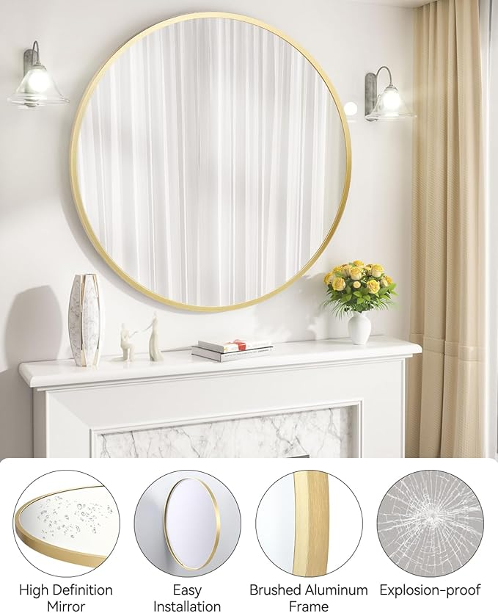

$37

Gold Round Mirror, 18 Inch Circle Mirror, 2024 New Gold Metal Frame Circle Mirror, Round Mirrors for Wall Decor, Round Wall Mounted Mirrors for Entryway, Bathroom, Bedroom, Vanity, Gold